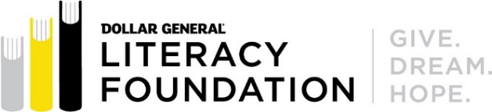 | 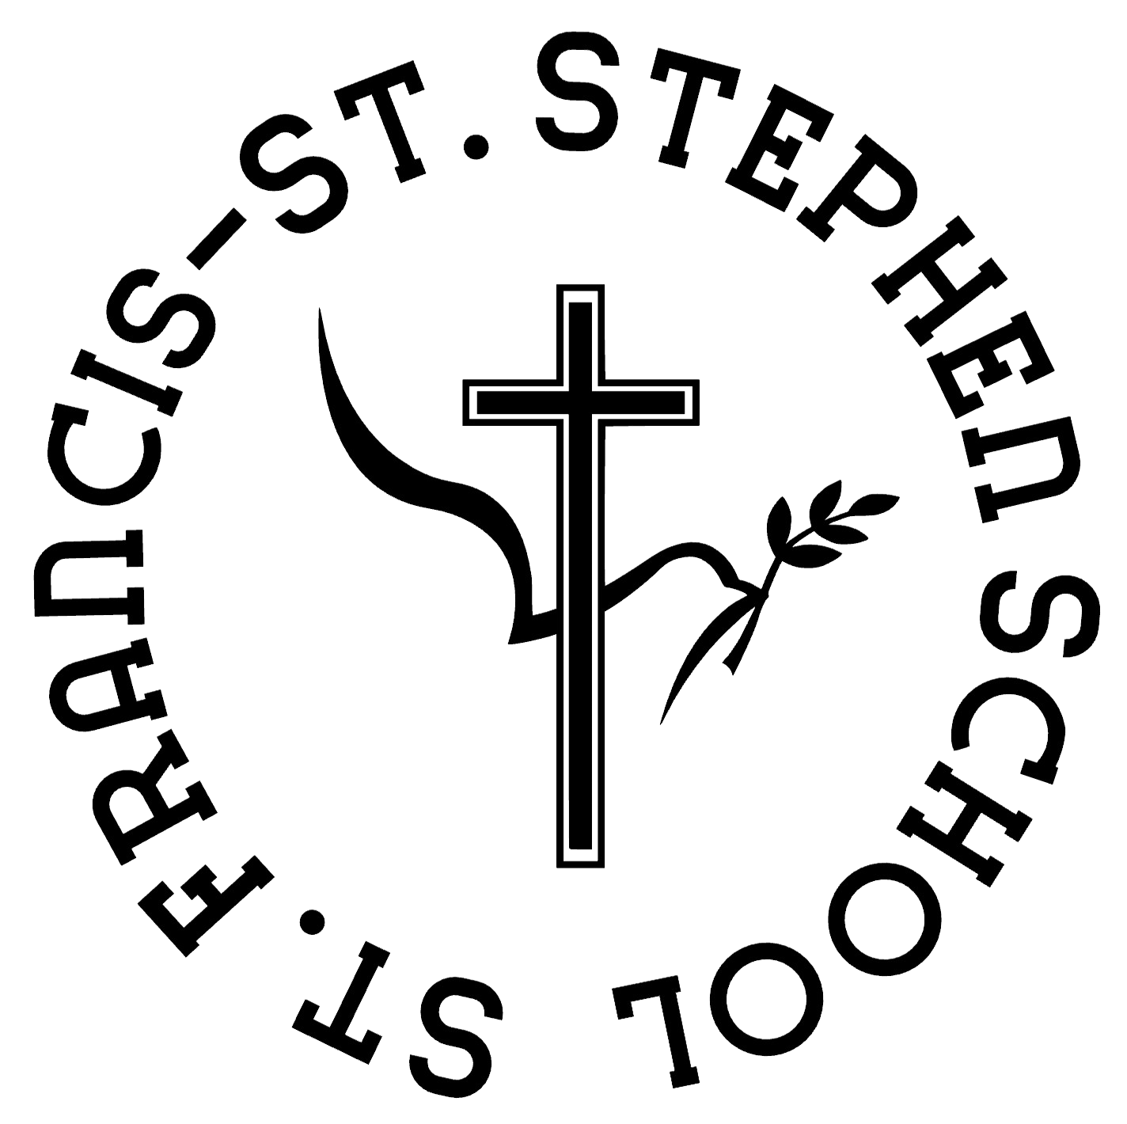
St. Francis – St. Stephen School Receives $500 Grant from the Dollar General Literacy Foundation to Support Youth Literacy
Geneva, NY – September 2024 – The Dollar General Literacy Foundation (DGLF) recently awarded St. Francis – St. Stephen School a $500 grant to support its youth literacy program. This local grant is a part of more than $4 million recently awarded to nonprofit organizations, libraries and schools in Dollar General’s hometown communities across the country to help extend a brighter future for K-12 students.

“We are deeply thankful for our valued community partnerships with businesses like Dollar General, whose unwavering support helps drive our initiatives forward. This year, our focus is on empowering students to close learning gaps and strengthen their literacy skills—a mission that requires both dedication and additional financial resources. With the generous support of partners like Dollar General, we can continue to make a meaningful impact in our students' educational journeys.”

In recent years, St. Francis – St. Stephen School has focused on helping students of all reading levels achieve growth. We've seen significant progress by providing books with spaced-out, bold fonts and expanding our library with decodable books to support struggling readers. This grant will help us purchase more of these books.

“We understand investing in youth literacy means investing in the future of students and our collective communities,” shared Denine Torr, executive director of the Dollar General Literacy Foundation. “Through these grants, we hope to enhance the programs’ efforts to foster students’ critical thinking skills, creativity and confidence so they can unlock their potential and achieve their dreams.”

The Dollar General Literacy Foundation supports organizations that increase access to educational programming, stimulate and enable innovation in the delivery of educational instruction and inspire a love of reading. Each year, DGLF awards funds to nonprofit organizations, schools, and libraries within a 15-mile radius of a Dollar General store or distribution center to support adult, family, summer and youth literacy programs. The Foundation also offers a student referral program for individuals interested in learning how to read, speak English, or prepare for the high school equivalency exam. Referrals to a local organization that provides free literacy services are available online here or through referral cards found in the Learn to Read brochures that are available at the cash register of every Dollar General store.

A comprehensive list of grant recipients may be found online at www.dgliteracy.org

About the Dollar General Literacy Foundation
The Dollar General Literacy Foundation is proud to support initiatives that help others improve their lives through literacy and education. Since 1993, the Foundation has awarded more than $254 million in grants to nonprofit organizations, helping more than 21.8 million individuals take their first steps toward literacy, a general education diploma or English proficiency. Each year, the Dollar General Literacy Foundation provides financial support to schools, nonprofit organizations and libraries within a 15-mile radius of Dollar General stores and distribution centers. To learn more about the Dollar General Literacy Foundation or apply for a literacy grant, visit www.dgliteracy.org.

