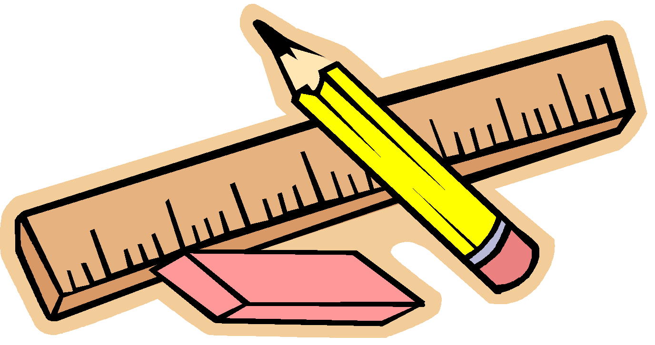

**SUPPLY LIST FOR GRADE 2**

* 2 reams of white copy paper (not needed the first day of school)
* Child scissors
* 1- 12” ruler with cm and inches
* 1 box of crayons (no more than 48 crayons in a box)
* Markers (thick & thin)
* 1 packages of Colored pencils
* 4-5 glue sticks
* T-shirt smock for art class-labeled
* 1 pink eraser
* Personal headset for computer (Please get headphones with a headband. They are much easier for the students to use and do not get tangled as easily.)
* 2 boxes of tissues plus 1 for specials
* 4 containers of antibacterial wipes plus 1 for specials
* 4 two-pocket folders with prongs, preferably plastic (Red, blue, green, yellow)
* 1- 1” Sturdy 3 prong Binder
* A roll of paper towels plus 1 for specials
* Reusable water bottle
* Ziplock Bags Gallon or quart size