Student Parent/Guardian Handbook
St. Francis deSales – St. Stephen School
17 Elmwood Avenue
Geneva, New York 14456
315-789-1828

2023-2024
Table of Contents
1.00 | WELCOME
1.01 | - Student Expectations
1.02 | - Parent/Guardian Expectations
2.00 | SCHOOL ADMINISTRATION
2.01 | - School Hours
2.02 | - School Faculty & Staff
2.03 | - School Dress-codes and Uniforms
2.04 | - School Closings & Weather Emergencies
2.05 | - Dignity for All Students
2.06 | - Attendance & Absence
3.00 | SCHOOL ADMISSION
3.01 | - Age Requirements
3.02 | - Immunization
3.03 | - Nondiscrimination
3.04 | - Lead Testing for Pre-School Students
3.05 | - Transfers
4.00 | SCHOOL CURRICULUM
5.00 | STUDENT HEALTH AND SAFETY
5.01 | - Administration of Medications at School
5.02 | - Emergency Treatment
5.03 | - Student Pregnancy
5.04  5.05  5.06  5.07 | - Child Protective Services Act  - Drug, Alcohol, and Tobacco  - Weapons on School Premises  - PESTICIDE NEIGHBOR NOTIFICATION LAW SECTION 409-H:
6.00 | FINANCIAL
6.01 | - Tuition
6.02 | - Parishioner Status
6.03 | - Delinquent Accounts
7.00 | TECHNOLOGY
7.01 | - Acceptable Use of the Computer Network and Internet Policy
7.02 | - Use of Electronics – Cell Phone
8.00 | PARENT INFORMATION & COMMUNICATION
8.01 | - Communication Flowchart
8.02 | - Media Release Statement
8.03 | - Appropriate Means of Communication

Mission Statement

The Diocese of Rochester Catholic Schools offer families an authentic Catholic education rooted in the Gospel of Jesus Christ and the teachings of the Roman Catholic Church.

Our schools:
- Guide students to be disciples who know and live the Catholic faith;
- Inspire a learning community to foster academic excellence; and
- Empower young people to fulfill the two great commandments of Jesus Christ by loving God and being service-oriented, responsible, and self-disciplined neighbors to others.
1.00 Welcome
Welcome to St. Francis deSales- St. Stephen School. We offer an authentic Catholic education rooted in the Gospel of Jesus Christ and the teachings of the Roman Catholic Church. Our high level of academic rigor provides students with a challenge to be their best. We guide, inspire, and empower young people to be disciples of Jesus Christ by loving God and our neighbors. SFSS is a learning community to foster academic excellence and live the Catholic faith.

  - Student Expectations
We value our students and hold them to the following expectations:
- Respect yourself and others.
- Put forth your best effort at all times.
- Attend and be prepared for class each day.
- Follow directions when given.
- Pay attention, participate, and ask questions.
- Preserve a positive learning environment.
- Take responsibility for your actions.

1.02 Parent/Guardian Expectations
The philosophy of the Diocese of Rochester Catholic School community is to proclaim the Gospel message of Jesus, educate the whole child, guide students in the love and service of God and others, and integrate Christian virtues (love, faith, hope, courage, reconciliation, and justice) into the curriculum.

By registering your child/ren at a Catholic school, parents/guardians become members of the school community of students, faculty, and staff that recognizes the mission of building Christ-like presence in our schools by instilling Christian values in our young men and women who will shape our future. By registering at a Catholic school, parents/guardians agree to uphold the policies, procedures, and decisions of the school as a partner in the education of each child. This partnership obligates all of us to share in the responsibilities for the education of children by agreeing to the following oath:

- I (We) fully understand the importance of guiding my (our) children's faith development, acting as a good Christian role model, actively participating in church membership and attending weekly Mass or church services.
- I (We) fully understand the importance of attending Parent Teacher Conferences at the teacher's request, cooperating with school staff, and being present at other school events to support my child/ren.
- I (We) understand the importance of reviewing my child/ren's homework daily.
- I (We) support and work with the faculty and staff to ensure a nurturing learning environment.
- I (We) agree to volunteer for events and projects within the school year.
- I (We) will ensure that students are picked-up from school and from school events on time.
- I (We) will register dissatisfactions and complaints in a reasonable and fair way, will not gossip, and will give everyone the benefit of the doubt by assessing the facts before passing judgment. Solutions to specific classroom issues must be sought at the level of the teachers before approaching the administration. The school expects that students and parents/guardians are respectful of one another, the faculty, and staff, including verbal, written, and face-to-face communications. Inappropriate and slanderous comments and/or social media behavior will not be tolerated and addressed appropriately by the school principal.
- I (We) will fulfill financial obligations to the school in a timely manner, including the payment of tuition, fees, and other expenses.

This promise is designed to implement the blessings of the Church-Family-School relationship. The Catholic school becomes a faithful atmosphere with the positive interaction of students, parents/guardians, teachers, administration, and support staff.

RESOLVING QUESTIONS OR CONCERNS
The mark of a Christian society is the way in which conflicts are resolved. Virtue and respect for others demand that questions or concerns be addressed directly to those involved and not discussed with others, requires an understanding that sometimes people have to “agree to disagree”, and that they not be presented to higher levels of authority unless previous attempts at resolution have been unsuccessful.

All interaction with faculty, staff, and administration should be by appointment. Parents/ Guardians should not expect availability on a “drop-in” basis. For the safety and security of all students and staff, visitors must report to the main office and be escorted throughout the building and abide by all safety policies and procedures set forth by the school.
- Questions regarding classroom order, expectations, grading, and other classroom related issues should be discussed directly with the teacher to address concerns.
- General questions regarding academics should be addressed to the teacher and then the Principal.
- Disciplinary issues should be addressed with the Principal.
- Financial questions should be addressed with the Business Office.

PARENT/GUARDIAN VOLUNTEERISM
We have an active group of volunteers – Volunteers are the main support system of every Catholic School. Please become involved in some capacity. The Principal expects every family will become involved in one of our celebrated events to support their child/ren and the school. As Jesus said, “I am the way and the truth and the life. No one comes to the Father, except through me” (John 14:6). In service to the children and the school, your gifts will be realized and valued.

All parent/guardian volunteers must complete the online Diocese of Rochester’s Creating a Safe Environment (CASE) for Volunteers Training (before volunteering at any event where students are present). Information is provided below:

Diocese of Rochester Volunteer Requirements
Catholic school system or in its parishes and related ministries fulfill the following criteria:
- Participate in or complete online a Creating a Safe Environment Training course (https://dor.safeenvironment.org)
- Complete and sign a Diocese of Rochester Volunteer Code of Conduct Form.
- Complete the Criminal Record Check process.
- If driving children, complete the Volunteer Driver Information Form and have driving record checked. This must be completed every year.

This is required to work with children in any capacity in our school - room parent, assist in the classroom, chaperone/drive on fieldtrips, athletic coach, and/or assistant at any social event where students are participating. All volunteers must participate in a renewal of training as determined by the Diocese of Rochester.

Don Cass is responsible for approving any volunteers. Completion of the training and background checks must be done at least one week prior to the event the volunteer would like to volunteer for. Any questions or assistance needed with this, please contact Don Cass at Donald.cass@dor.org .
2.00 School Administration

  - School Hours

The School Day begins at 8:15 AM and ends at 2:15 PM. For safety and security reasons, students are not allowed to enter the school building or be on school grounds before 8:00 AM or after 3:00 PM, unless attending an authorized school program or function.

Visitors must buzz in at the side door off of the small parking lot facing the Rectory. You will be asked to sign in and out.

  - School Faculty & Staff

Preschool 3 Mrs. Huling
Pre-K 4 Mrs. Huling
Kindergarten Mrs. Sindoni
1st Grade Mrs. Iannopollo
2nd Grade Mrs. Tulloch
3rd Grade Mrs. Calabrese
4th Grade Ms. Sykes
5th Grade Mr. Addyman (5-8 Math, 7 & 8 Science)
6th Grade Ms. Parmele (5-8 Social Studies, 5 & 6 Science)
7th Grade Mrs. Kehoe (6 & 7 Religion, 6-8 Spanish)
8th Grade Mrs. Caster (5-8 ELA, 5 Religion)
Algebra 1 Ms. Pohorence
PE/Health Mr. Spink
Art Ms. Long
Music Mrs. Ciancaglini
SPED Mrs. Stitt
Secretary Mrs. Liberatore
Admin Asst

  - School Dress-code and Uniforms

The purpose of the dress code and uniform policy has always been to help students accept responsibility for modesty and good grooming; to take pride in their appearance; and to represent our school in a manner of which we can all be proud.

Pre-school, Pre-Kindergarten, and Kindergarten students are not required to wear uniforms. They must be dressed appropriately and modestly. It is recommended that girls wear shorts or leggings under skirts or dresses. See dress code notes under the uniform table.

Dress Uniforms may be purchased through Land’s End or www.frenchtoast.com . Search using school code: QS61K1P. Items in the uniform store have been approved by the administration. We do have some gently used uniforms available at the school. PE shirts are purchased through a different company.
Boys’ Dress Uniform | - Solid gray or red polo shirt – long or short sleeve  - Navy blue chino dress pants  - Grades 5-8 – black, brown, or blue belt  - Solid, navy blue sweater vest, pullover sweater, or button up cardigan or gray quarter zip fleece(optional, before October 12th or after May 1st)  - Plain navy, black, or brown closed toe, closed back dress shoes; Navy, white, black sneakers
Girls’ Dress Uniform | - Solid gray or red polo shirt – long or short sleeve  - Red/gray plaid jumper or skirt (Skirt length must be knee length, but not shorter than mid- thigh.)  - Solid navy skirt (Skirt length must be knee length, but not shorter than mid- thigh.)  - Solid white, red, or navy socks or tights.  - Navy blue chino dress pants  - Grades 5-8 – black, brown, or blue belt to be worn with pants.  - Solid, navy blue sweater vest, pullover sweater, or button up cardigan or gray quarter zip fleece (optional, before October 12th or after May 1st)  - Plain navy, black, or brown closed toe, closed back dress shoes; Navy, white, black sneakers
PE Uniform | - Gray t-shirt (long or short sleeve) with school logo on front  - Solid red sweatshirt or gray quarter zip fleece (May be worn with dress uniform.)  - Solid navy blue sweatpants (Shorts may be worn under sweatpants and sweatpants remove for PE class.)  - Navy, white, black sneakers  *Change of footwear must be brought on snowy/rainy days to protect the gym floor.
Optional Summer Uniform  (May be worn first day for school until October 12th; May 1st until end of school.) | Dress uniform options:  - Solid navy dress shorts (Shorts must be mid-thigh length.)  - Solid gray or red polo shirt with school logo.  - Solid white, navy, or black sneakers  PE Uniform options:  - Solid navy mesh shorts (Short length must knee length, but not shorter than mid- thigh.)

Accessories, shoes, jewelry, etc.
- Sandal, Crocs, open toe, or open backed shoes not permitted for safety reasons.
- Small hoop or dangle earrings are permitted. Boys are not permitted to wear earrings.
- No smart watches are permitted. (Students will be asked to put these in their locker.)
- Modest jewelry maybe worn (single bracelet, single ring, watch, chain necklace with small charm.
- Hair should be clean, well-groomed, and not falling into eyes.
- No extreme hairstyles are permitted, such as mohawks, shaved designs, elongated sideburns, etc. (Administration reserves the right to determine what is considered extreme or distracting.)
- Natural color of hair must be maintained including casual dress days.
- Girls may wear plain red, navy, black, or white flat headbands, hair ties, ribbons, or hair clips. Cat, unicorn, or other headbands with themes are not permitted.
- No makeup is to be worn.
Casual Dress Days (Non-Uniform Days)
These are noted on the school calendar or in the weekly family communication. Please follow these guidelines for these days:
- Dress needs to be modest and appropriate for the weather.
- Clothing with inappropriate graphics or messages is not permitted.
- No spaghetti straps, sheer material, or cropped shirts.
- Ripped or stained clothing is not permitted.
- Clothing should fit appropriately, not body conforming.

  - School Closings & Weather Emergencies

Families will receive an automated phone call, text, and/or email for any SFSS School Closing or Delay. We follow Geneva CSD closings and delays, which are televised on WROC TV 8 or our Facebook page.

If your child does not have transportation due to bussing from a district outside of Geneva, your student is legally absent.

  - Dignity for All Students Act

St. Francis- St. Stephen School adheres to the New York State’s Dignity for All Students Act (“The Dignity Act”) which seeks to provide a safe and supportive environment free from discrimination, intimidation, taunting, harassment, and bullying on school property, a school bus, and/or at a school function. All Diocese of Rochester Catholic Schools have implemented the Caring School Community Program, which is based on over 35 years of research, dedicated to effecting positive change at schools by utilizing four essential social environments: community, school, classroom, and individual. The Caring School Community Program effectively trains our school leaders and school teachers on the latest research regarding bullying and effective methods to prevent it and address it. Diocese of Rochester Schools have pledged to eliminate bullying and harassment as best as possible by not only posting and enforcing school wide rules against bullying and harassment, but by applying our key instrument: involving parents/guardians.

  - Attendance & Absence
Regular student attendance is an integral factor in maintaining a quality educational program and is one of the most powerful factors of a student’s success in school.
Parents/Guardians must notify the Main Office at 315-789-1828 option 1 to report student absences.
Approved excused absences are defined as:
- Sickness
- Serious family illness
- Death of a family member of close friend
- Religious
- Medical or Dental Appointment
- Court
- Approved school-related program
EXCESSIVE ABSENCES
Excessive may be interpreted as a large number of absences over a period of time that causes the student to lack the ability to demonstrate proficiency of learning or the concepts taught. Long term medical absences (more than 3 consecutive days or recurring medical situations) require a medical note from the attending doctor. Long term medical or other legal, atypical absences may be exempt from the listed truancy interventions.
The school and diocesan administration reserves the right to determine what is considered excessive and may address truancy with one or more of the following interventions (not limited to this list):
- Meeting with the parents/guardians
- Referral to counseling sessions
- Referral to social services
- Limit eligibility for academic/extracurricular privileges
- Grade retention
- Withdrawal/unenrollment from the school

3.00 School Admission

  - Age Requirements

New York State Law requires children entering Kindergarten must be five years of age on or before December 1 of the entering year. Similarly, children entering a pre-school program for four-year-olds must be four on or before December 1 of the entering year. The same rule applies for three-year-olds.

  - Immunization

The Diocese of Rochester and its Affiliated Employers follow New York State Public Health Law requires every student entering school to be immune to diphtheria, tetanus, pertussis, measles, mumps, rubella, poliomyelitis, hepatitis B, varicella and meningococcal in accordance with Advisory Committee on Immunization Practices (ACIP) recommendations, NYS Public Department of Health Immunization Laws and Regulations. Exceptions may be granted for medical or religious reasons.

  - Nondiscrimination

Title IX – Nondiscrimination, Harassment, and Bullying: Diocese of Rochester and its Affiliated Employers personnel must follow regulations of Title IX and the guidelines of the nondiscriminatory policy of the Federal government. Diocese of Rochester and its Affiliated Employers will not discriminate in the administration of their educational policies, admission policies, scholarship and financial aid programs, athletic and other school-administration programs. It is the responsibility of the principal (Title IX Coordinator), teachers and staff, students and parents/guardians to create an environment free from harassment, bullying and discrimination.

All students have equal educational opportunities at St. Francis- St. Stephen School without regard to any legally-protected category under federal or state law. Moreover, harassment against students on the basis of a protected category will not be tolerated.

If you believe you or another person has been discriminated against, harassed or denied an opportunity on the basis of any protected category, please promptly contact Suzanne Pohorence, the Title IX Coordinator, at 315-789-1828 to report your concerns. All concerns reported will be promptly and thoroughly investigated/ reviewed. Confidentiality will be maintained to the greatest extent possible under the circumstances. Retaliation against persons who raise concerns is strictly prohibited. If you believe you have suffered reprisal for raising concerns, please contact the Title IX Coordinator to report your concerns.

  - Lead Testing for Pre-School and Kindergarten Students
New York State Public Health Law requires proof of lead testing for admission to preschool and kindergarten in order to be compliant with the New York State Lead Poisoning Act.

  - Transfers
Students with past due balances will not be accepted at any other Catholic school within the Diocese of Rochester until the past due amount is resolved.

4.00 School Curriculum

Our curriculum is unique to the individual teacher and school as it integrates our faith and includes all teaching and learning experiences. All curriculum in our schools meets and exceeds the minimum learning standard requirements set forth by New York State. Teachers are expected to use a variety of resources to devise lesson plans and tailor instruction to the individual needs of their students. Teachers of all subject areas are encouraged to collaborate to show the connection between subject areas and allow for students to apply knowledge and skills in preparation for college and careers.
Religion is taught daily as a core subject as well as integrated into all subject areas and aspects of the school day. Prayer occurs multiple times daily and the integration of religious values within other subject areas is the constant responsibility of all faculty and staff.
Faith, Assessment, Curriculum and Excellence guides curriculum and instruction in our schools. The document is available online at the Diocese of Rochester Department of Catholic Schools' website (www.dorschools.org)

4.01 Grading and Report Cards
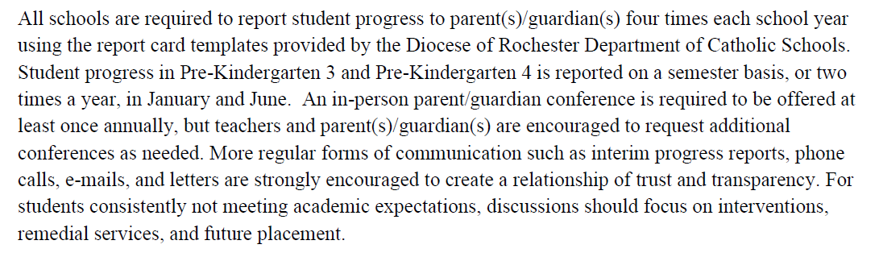
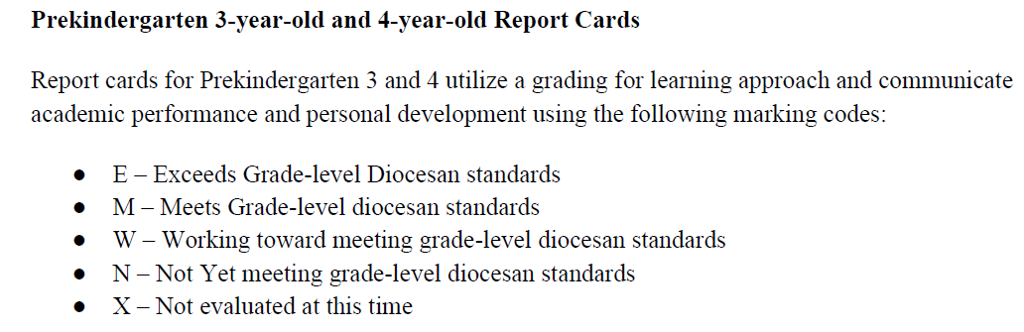
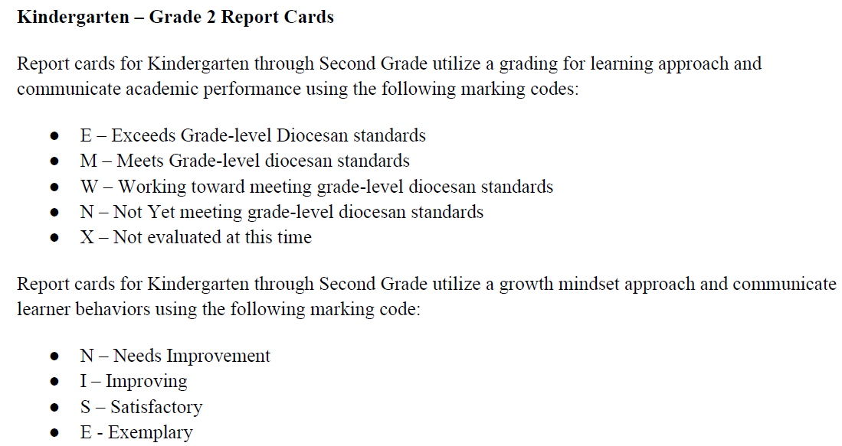
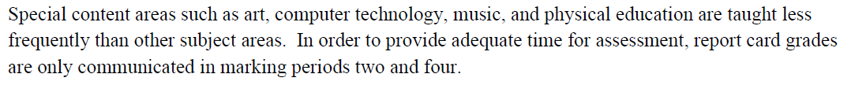
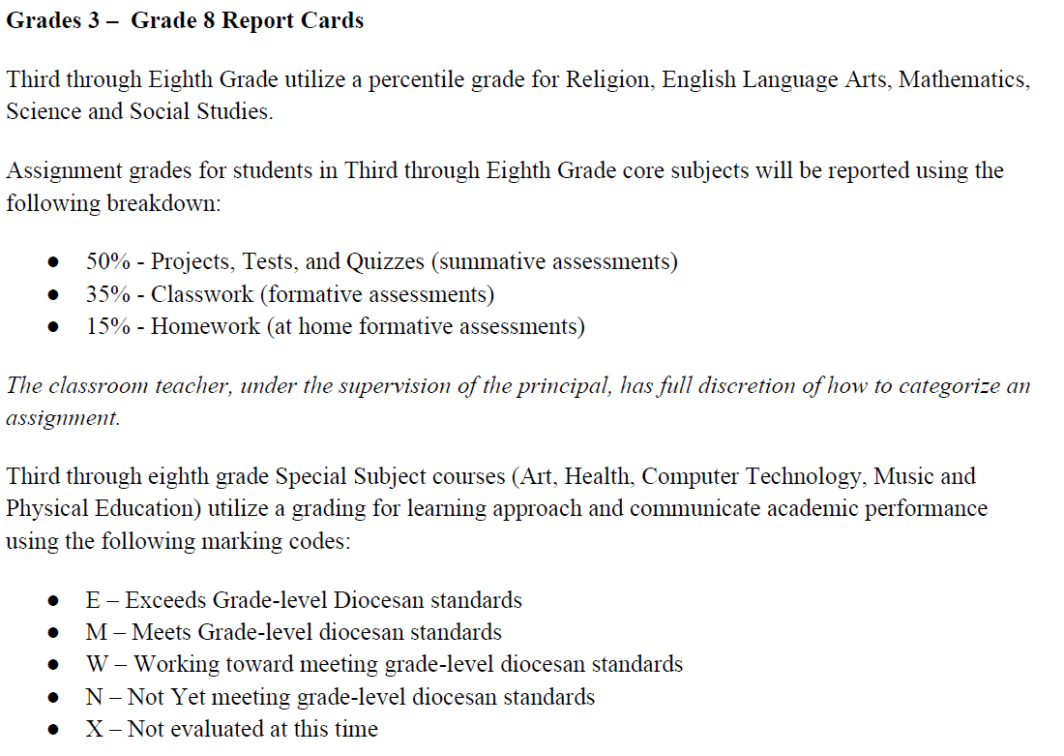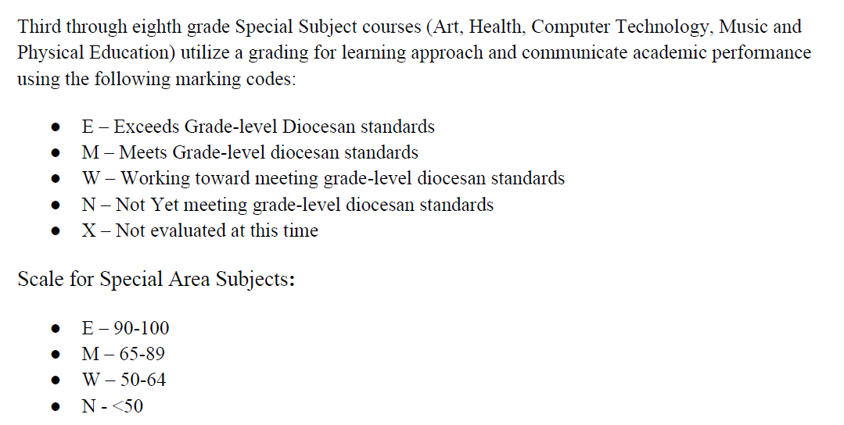
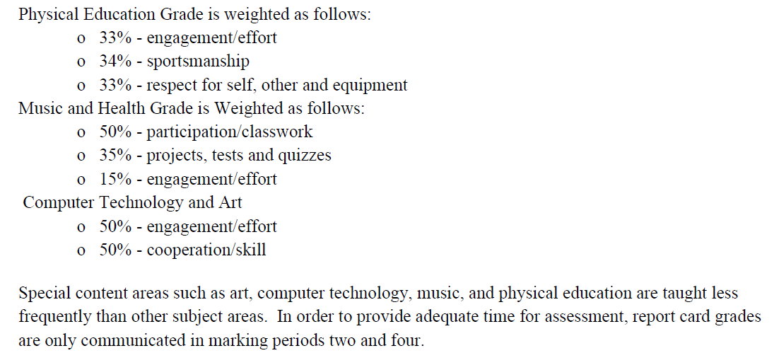
4.02 HONOR ROLL
Students in grades seventh and eighth are eligible for High Honor Roll and Honor Roll each marking period. The Qualifications for honor roll are:
- High Honor Roll (HHR) – Minimum 95.0 average in each of the core subjects of Religion, ELA, Math, Science, and Social Studies and 85.0 minimum grade of a grade of E or M in special subject areas of World Language, Health, Music, Art, Physical Education, and Technology. Students will not be considered for High Honor Roll if they have earned an N for any Learner Behaviors.
- Honor Roll (HR) – Minimum 85.0 average in each core subject of Religion, ELA, Math, Science, and Social Studies and 80.0 minimum grade of a grade of E or M in special subject areas of World Language, Health, Music, Art, Physical Education, and Technology. Students will not be considered for Honor Roll if they have earned an N for any Learner Behaviors.
4.03 Student Work and Academic Integrity
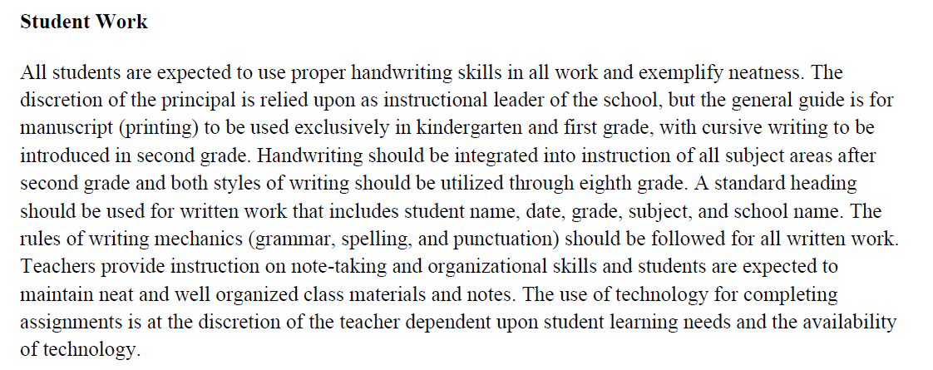
Academic Integrity
Academic integrity is one of the values we uphold in our students. Students are expected to complete their work to their best ability and represent it as their own. Plagrisism and work submitted as not the student’s work will not be accepted and teachers may refuse to grade the work or give an appropriate score that is reflective of the student’s own work.

5.00 student health and safety

  - Administration of Medications at School

Prescribed medications will only be dispensed by the school nurse, doctor, or other health professional when the “Parental Authorization for Administration of Medications in School” is completed and returned to the school. In the absence of the health care professional, there will be a designated staff member who has been properly trained to administer medication, in most cases the administrative assistant or the principal. Additional document includes a written order from a health care professional stating the drug to be given and the time and dosage. In keeping with New York State law, medications must be transported directly by the parent/guardian to the school (medications CANNOT be transported on the school bus).

  - Emergency Treatment

If a student becomes ill during school hours, the parent/guardian will be notified. Each year an “Emergency Treatment of Students” from must be completed and returned to the school. This form summarizes emergency contacts, medical conditions, medications, and allergies.

  - Student Pregnancy

The Diocese of Rochester maintains a pastoral approach to ministering to the needs of female and male students involved in a pregnancy as well as to their families. Each such case will be treated individually by the Principal and Pastor/Pastoral Administrator in consultation with the family.

  - Child Protective Services Act

Under the New York State Child Protective Services Act, school personnel who “suspect” that a child coming before them in their “professional capacity” is being abused, maltreated, and/or neglected are mandated to report this suspicion to the New York State Central Register for Abuse and Maltreatment. All school faculty and administration are mandated reporters. All Diocese of Rochester Schools are legally and morally bound to make such reports and will contact the local Department of Social Services when necessary.

  - Drug, Alcohol, and Tobacco

Student use, possession, sale, conveyance, distribution or manufacture of controlled substances (as defined by New York Penal Law and Title 21 of the Code of Federal Regulations) and/or illegal drugs is expressly prohibited on parish, school, or diocesan (including vehicles) property. Underage possession or use of alcohol and tobacco on parish, school, or diocesan (including vehicles) property is strictly prohibited. Students shall not be under the influence of alcohol or other prohibited substances on parish, school or diocesan grounds or at parish, school or diocesan-sponsored events.

School authorities (minimum of two adults) may conduct a search of a student's book bag, locker, and/or a personal search of a student when there is sufficient cause to believe that drugs, alcohol, tobacco, weapons or other materials are hidden

Local police must be called to investigate suspicion of a violation of this policy. Anyone on school premises who is taking drugs prescribed by a physician, dentist, or other licensed practitioner which may affect their ability to function in the school environment, should bring this information to the attention of the principal. Prior to the ingestion of any such prescribed medication every student must provide to the principal a written statement from the prescribing practitioner that identifies any restrictions that the medication may necessitate.

New York State Law prohibits smoking in all parish and diocesan buildings as well as anywhere on school grounds. Students may not smoke on school grounds at any time. For purposes of this policy, smoking includes the use of any tobacco products, such as lighted or unlighted cigarettes, cigar, cigarillo, pipe, bidi, clove cigarette, spit/spitless tobacco and any other smoking or tobacco product. The use of e-cigarettes and any other products containing nicotine is also prohibited.

Compliance with this policy is a condition of enrollment, and any student who engages in any such behavior may be subject to disciplinary action, up to and including expulsion.

  - Weapons on School Premises

No implement that can be construed as a weapon (e.g., firearms, knives, large sticks, matches, lighters, or the like) will be allowed on school or parish grounds. Appropriate disciplinary action should be taken if a weapon is found including contacting the police, if the student possessing the weapon is considered to be jeopardizing the safety of themselves and/or others. In the event of contacting the police, the Diocese (Department of Catholic Schools and the Chancellor’s office) must be notified immediately.

School officials must cooperate with law enforcement officers who come to the school for purposes of questioning pupils. Cooperation with police will be done in such a way as to protect the legal rights of each individual student.

5.07 PESTICIDE NEIGHBOR NOTIFICATION LAW SECTION 409-H:
In adherence to New York State Section 409-H Education Law, St. Francis – St. Stephen School does not use any pesticide products in its school or on its grounds.

6.00 Financial

  - Tuition

The annual tuition at St. Francis- St. Stephen School is $4,285 for parishioner and $6,080 for non-parishioner. With discounts for additional children in family. Tuition payment options are annually, semi-annual, quarterly, and monthly.

  - Parishioner Status

Families are granted parishioner status by Pastor/Pastoral Administrator authorization. Neither St. Francis- St. Stephen School nor the school principal has the authority to grant parishioner status.
Should a discrepancy arise regarding a family’s parishioner status, it must be resolved through their home parish. It is the responsibility of the family to resolve the discrepancy with the Pastor/Pastoral Administrator, not St. Francis- St. Stephen School or the school principal.

  - Delinquent Accounts

Families that are one payment in financial delinquency will be notified by FACTS as being past due. The Pastor/Pastoral Administrator, Business Manager/Finance Director and Principal will be notified of the past due status.
Families with balances greater than 60 days past due will not be permitted to return to school until the outstanding balance is resolved.
St. Francis- St. Stephen School will pursue every avenue to obtain tuition and extended care payment, including collection agencies and legal options. Academic records and transcripts will not be released until the outstanding balance is paid in full, as well as any collection fees incurred.

7.00 Technology

  - Acceptable Use of the Computer Network and Internet Policy

It is the policy of St. Francis- St. Stephen School to require the ethical use of the Internet and related technologies by all employees, volunteers, and students as set forth below in the " St. Francis- St. Stephen School Acceptable Use of the Computer Network and Internet Policy.” Access privileges may be revoked, administrative disciplinary action may be taken, and/or appropriate legal action taken for any violations that are unethical and may constitute a criminal offense.
Internet Terms, Conditions, and Regulations
Acceptable Use
Use of the Internet and related technologies must be in support of education and research and consistent with the educational objectives of St. Francis- St. Stephen School. Use of other organizational networks or computing resources must comply with the rules appropriate for these networks.
Unacceptable Use
Transmission of any material in violation of any national, state or Diocesan policy or law is prohibited. This includes, but is not limited to, copyright materials, threatening, violent, or obscene material or material protected by trade secret. Use for commercial activities is not acceptable. Use for product advertisement, unauthorized chat or chain letter communication or political lobbying is also prohibited. Other examples of unacceptable information are pornography, information on bombs, inappropriate language and communications, flame letters, or like material.
Acts of vandalism are prohibited. Vandalism is defined as any malicious attempt to harm or destroy data of another user, or to damage hardware or software. This includes, but is not limited to, the uploading or creation of computer viruses. Unauthorized use of another's computer, access sign-on and/or password and/or accounts, and/or files is prohibited.
Privileges
The use of the Internet and related technologies is a privilege, not a right. Inappropriate use may result in cancellation of those privileges. Each user, who is provided access to Internet and related technologies, will participate in a discussion with assigned staff person(s) concerning the proper use of the network. The faculty, staff, or parent/guardian may request the administrator or designee to deny, revoke, or suspend a specific user access to the Internet and related technologies due to unacceptable use.
Warranties
The educational programs governed by St. Francis- St. Stephen School make no warranties of any kind, whether expressed or implied, for the service it is providing and will not be responsible for any damage’s users may suffer. This includes loss of data resulting from delays, non-deliveries, mis-deliveries, or service interruptions. Use of any information obtained via the Internet and related technologies is at the user's own risk. The educational program governed by St. Francis- St. Stephen School specifically denies any responsibility for the accuracy or quality of information obtained through its services. The computer user will be responsible for any financial obligation incurred through the use of Internet and related technologies that are not previously approved as part of the school budget.

Acceptable Student Use of the Computer Network and Internet Policy
Rules and Responsibilities:
Access to the Internet will enable students to explore thousands of school-related libraries, databases, and research media. While St. Francis- St. Stephen School’s intent is to make Internet access available to further educational goals and objectives, students may find ways to access objectionable material as well. St. Francis- St. Stephen School believes that educational benefits to students from accessing the Internet, in the form of information, resources, and opportunities for collaboration, exceed any disadvantages.
To that end, St. Francis- St. Stephen School has set the following standards for acceptable student use of on-line information sources via the Internet.
- Students are responsible for good behavior on school computer networks, just as they are in the classroom. Communications on the network are often public in nature. The Internet network is provided for students to conduct research and communicate with others as a regular part of the curriculum. Access to Internet network services is given to students who agree to act in a responsible manner. Parental permission is required, and access is a privilege - not a right.
- Network administrators and teachers may review files and communications to maintain system integrity and ensure that users are employing the system responsibly. Network storage areas will be monitored regularly. Users should not expect that files used or stored on school computers or servers would always be private.
- Access to information will be honored within reason. During school hours, teachers will guide students toward appropriate materials. Outside of school, families bear the same responsibility as they would when guiding their children with information sources such as books, periodicals, television, telephones, movies, radio, and other potentially offensive media.
- The following list describes behaviors and/or actions that are not permitted. The principal, as school administrator, has final authority to determine what behaviors and/or actions are unacceptable:
- Sending, displaying, or downloading offensive messages or pictures;
- Using obscene language;
- Harassing, insulting, or threatening others;
- Damaging of computer systems or computer networks;
- Violating copyright laws;
- Submitting documents from the Internet as a student's personal work;
- Using another person's sign-on and/or password;
- Trespassing in someone else’s folder, work, or files;
- Intentionally wasting limited resources;
- Using the network for commercial purposes;
- Revealing a personal phone number, name or address of one's self or another;
- Any other form of cyber bullying.
- Violations will result in loss of access as well as other disciplinary action as determined by the school principal.

7.02 Use of Electronics – Cell Phone and Other Electronic Devices
Neither the Diocese of Rochester nor the school is responsible for any electronic items brought to school; including cell phone, tablets, smart watches, or any digital equipment. All electronic communications devices are subject to the Acceptable Use of the Computer Network and Internet policy.

Devices such as personal cell phones, smart watches, digital music players/Bluetooth speakers, tablets, personal gaming devices, etc. will remain in student backpacks in their lockers throughout the school day.

Communication using these devices will only be permitted when given permission from a supervising adult.
8.00 pARENT INFORMATION & COMMUNICATION

  - Communication Flowchart

As a Catholic school community, we recognize the role of parents/guardians as the primary educators of their children. Therefore, we value communication as a key to the success of all children entrusted to our care. This communication flow chart serves as a guideline and should assist parents/guardians and school community members in contacting the appropriate school staff members with questions or concerns. We encourage you to contact the staff member most immediately involved with your question or concern as the first contact. If the issue is not resolved, please progress through the flow chart below.

Questions/ Concerns | First Contact | Second Contact | Third Contact
Academics | Teacher | Principal
Athletics/CYO | Coach | Athletic Director & Principal | Director of CYO Sports
Behavior | Teacher | Principal
Extra-Curricular Activities | Club Advisor | Teacher | Principal
Financial Aid | Business Office | Principal | Pastor/ Pastoral Administrator
Medical | School Nurse | Teacher | Principal
Religion | Teacher | Principal | Coordinator of Curriculum & Instruction
Safety | Teacher | Principal
Special Education | Teacher | AIS Teacher& Principal | K-8th: District of School Location; Pre-K: District of Residence
Transportation/ Bus Behavior | Driver | Principal | Transportation Department of District of Residence
Technology | Teacher | School Technology Coordinator | Principal
Tuition Payment | Tuition Management Company, if applicable | Business Office | Principal
Use of Facilities | Parish Office | Principal | Pastor/ Pastoral Administrator

Additionally, the Superintendent of Schools is the Fourth Contact.

  - Media Release Statement

St. Francis- St. Stephen School subscribes to the following photo release policy:
Minors:
Photos and images of minors (children under 18 years of age) may be included in print and Web publications only when the parent/guardian sign Model Release that was part of the FACTS enrollment packet.
If no Model Release is available, photos and images of minors may only be included in print and Web publications and video productions when the minors’ faces are indistinguishable (ie, turned away from the camera or otherwise unidentifiable).
Adults:
St. Francis- St. Stephen School does not require signed release form to publish images of adults.

8:03 Appropriate Means of Communication

Our community values respect. St. Francis – St. Stephen School faculty and staff can be reached via the school phone and their school email during school hours during the school year. The school will not share with families or the community faculty and staff personal emails or cell phone numbers.
Faculty may choose to use a group communication site (Talking Points, Class Dojo, Google Classroom, etc.) or digital/paper newsletter/memo (S’more, etc.) to communicate to the class or individual parents.
Both faculty, staff, and families understand that responses and information shared via the means mentioned above, need to be respectful and considerate. Responses from either the sender or recipient need to be timely, but not instant. Please give either party 24-48 hours to respond.

Parent/Guardian Agreement Form
Please complete one form per family and return to school by the first day of school.

Parents/guardians are asked to complete this form after reading the school handbook and discussing the “St. Francis-St. Stephen Handbook and Acceptable Student Use of the Computer Network and Internet Policy” with their child(ren). This document will be kept at the school for the duration of the student’s attendance.
Parent/Guardian Support for Acceptable Computer Network Guidelines and Parent/Guardians Expectations:
As the parent and/or guardian of _________________________________________________________, I have read and will support terms described in the “St. Francis-St. Stephen Acceptable Student Use of the Computer Network and Internet Policy”, as well as the “Parent/Guardian Expectations.” I have instructed my son/daughter to cooperate with and support the rules and guidelines set forth in the “St. Francis-St. Stephen Acceptable Student Use of the Computer Network and Internet Policy.” I understand my son/daughter will be held responsible for any non-compliance with the stated policy’s rules and responsibilities.”
Signature of Parent / Guardian Date

Signature of Parent / Guardian Date

